10 DAYS GORILLAS &BIG FIVE (QUEEN ELIZABERTH, MURCHISION FALLS NATIONAL PARKS AND ZIWA RHINO SANTUARY)

Bwindi Impenetrable Forest National Park,Kibale Forest National Park and Queen Elizabeth National Park has a diverse ecosystem which include a sprawling savanna, sparkling lakes, humid forests, fertile wetlands which makes it a suitable home for over 600 species of birds, outstanding wildlife attractions like tree climbing lions, chimpanzees among others. The Park is set against the beautiful sceneries of the Rwenzori Mountains, the panoramic view of kazinga channel.

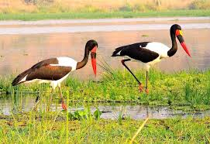

**DAY 1: ARRIVAL AT ENTEBBE INTERNATIONAL AIRPORT**

You will be welcomed by a representative of FRIENDS NATURE SAFARIS If you arrived at the airport early we may just drive BWINDI IMPENETRABLE NATIONAL PARK FOR GORILLAS.

**DAY 2: KAMPALA – BWINDI IMPENETRABLE NATIONAL PARK**

Early morning we shall do safari walk around the park to see animals like Giraffes, Kobs, Zebras and many more, breakfast then leave for Bwind Impenetrable National Park .We shall drive via a scenic route, savanna vegetation and Ankole cattle and precede our drive through the green growth countryside, we shall have lunch on the way and final we arrive in Bwindi and check in at our Lodge for dinner and overnight at Silver Back Lodge Luxury (Any Equivalent).

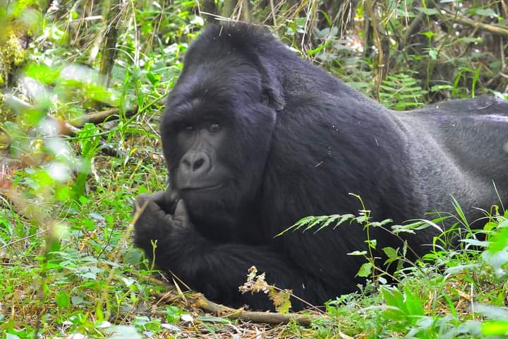

[DAY 3: BWINDI IMPENETRABLE FOREST NATIONAL PARK](http://www.friendsnaturesafaris.net)

In the morning we take our breakfast and assemble for briefing according to the group which we are going to trek/track about the does and donots.This activity is one of highlight of our safari, meeting with the gentle giants of Bwindi, Especially hikers will love the gorilla trekking in the beautiful ecosystem of the park. It is difficult to foresee how many hours you will hike, it may take two to eight hours. Expect to walk a long distance in steep and muddy conditions, sometimes with rain overhead, before you encounter any gorillas. But we found these creatures it is very rewarding and interesting as you observe them closely while they eat, play and rest. A unique and unforgettable experience! For conservation purposes, time spent with the gorillas is limited to one hour. The ranger guide always briefs you on how to behave with these giant apes. After the trek we return back to lodge for lunch and evening at leisure. Dinner and overnight at Silver Back Lodge Luxury (Any Equivalent).

**DAY 4: BWINDI IMPENETRABLE TO QUEEN ELIZABETH NATIONAL PARK**

After breakfast you can choose to have a guided village walk for a closer meeting with the local community. Learn about their way of living as you walk through coffee, tea and banana plantations. Afterwards we depart to Queen Elizabeth National Park. We will pass the southern sector of the park, called Ishasha and known for the tree-climbing lions and here we expect to see some of the lions resting on the branches of trees. While we continue to our accommodation in the middle of the national park be alert to spot some wildlife like kobs, waterbucks and warthogs while grazing. Dinner and overnight at Mweya Safari Lodge Luxury (Any Equivalent)

**DAY 5: QUEEN ELIZABETH NATIONAL PARK. (GAME DRIVE AND BOAT CRUISE**

At the park, early morning, wake up take a cup of tea and head for the thrilling game drive at 6:00am. Game to view Lion, Elephant, Leopard, Buffalo, Hyena and a variety of Antelope species. After lunch enjoy the unique 2-hour boat ride on the Kazinga Channel. You will have a chance to view Hippos on close range, have a boat cruise at kazinga chanel, watch other bird species and there after transfer back to the lodge for Dinner and overnight at

• Accommodation: Enganzi Lodge in Queen Elizabeth National park

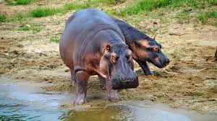

**DAY 6: TO KIBALE FOREST NATIONAL PARK (CHIMPANZEELAND).**

Depart for KIBALE FOREST NATIONAL PARK in the western part of Uganda and is which is known for 13 species primates. It will take approximately 3-4 hours, In the morning, Travel from Queen Elizabeth National Park to tourism city Fort- Portal, taking a scenic drive through the crater lakes region upon arrival in Fort Portal have lunch then drive to KIBALE FOREST NATIONAL PARK and retire to our hotel for dinner and accommodation.

• Accommodation

**DAY 7: TO KIBALE FOREST NATIONAL PARK (CHIMPANZEELAND).**

After breakfast we get briefed from our centers about Chimpanzee Tracking then we enter the Forest in Search of the Chimps, Kibale Forest is known for harboring the 13 different species of Primates in Africa, we find them take pictures with them. Then after that we travel to back to our hotel for Lunch and Evening at leisure.

• Accommodation

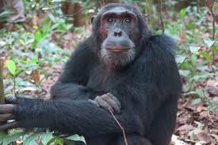

**DAY 8: KIBALE FOREST NATIONAL PARK FROM KAMPALA**

After breakfast, we drive from Kibale Forest National to Kampala cityLunch onthe way then we arrive at our hotel check-in.

**• Accommodation**

**DAY 10: KAMPALA/ENTEBBE TO AIRPORT**

After breakfast depending on the time of your flight if its in the evening or at night we can do an Excursion during the day before going to the Airport back home.